Practical No.02

Q.1] Print list of elements using for loop

<!DOCTYPE HTML>
<HTML>
<head>

<link rel="stylesheet" href="https://pyscript.net/releases/2025.8.1/core.css"/>
<script type="module" src="https://pyscript.net/releases/2025.8.1/core.js"></script>
</head>

<body>
<h3>Print list of elements using for loop</h3>

<script type="mpy" terminal>
arr = [10,20,30,40]

for i in arr:
print(i)
</script>
</body>
</HTML>
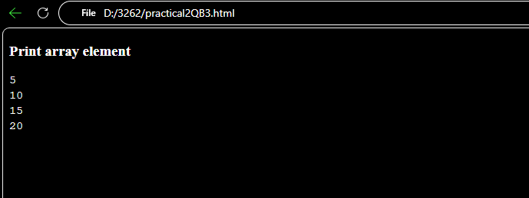
Q.2] Print Your Name…

<!DOCTYPE HTML>
<HTML>
<head>

<link rel="stylesheet" href="https://pyscript.net/releases/2025.8.1/core.css"/>
<script type="module" src="https://pyscript.net/releases/2025.8.1/core.js"></script>
</head>

<body>
<h3>Print Your Name</h3>

<script type="mpy" terminal>

print("Hello DYP")

</script>
</body>
</HTML>

Output :-

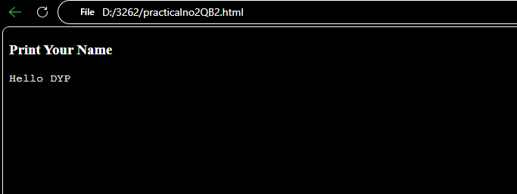

Q.3] Print list of elements using for loop

<!DOCTYPE HTML>
<HTML>
<head>

<link rel="stylesheet" href="https://pyscript.net/releases/2025.8.1/core.css"/>
<script type="module" src="https://pyscript.net/releases/2025.8.1/core.js"></script>
</head>

<body>
<h3>Print list of elements using for loop</h3>

<script type="mpy" terminal>
arr = [10,20,30,40]

for i in arr:
print(i)
</script>
</body>
</HTML>

Output :-
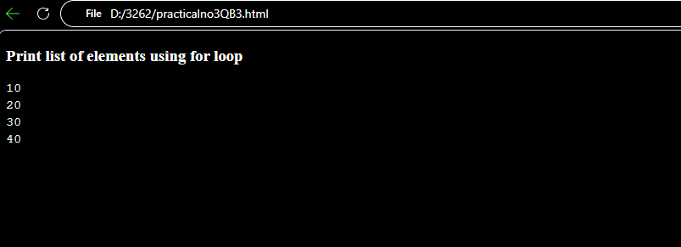
Q.4] ( Exercise ) Write py-script to display todays date in browser.

<!DOCTYPE HTML>
<HTML>
<head>
<link rel="stylesheet" href="https://pyscript.net/releases/2025.8.1/core.css"/>
<script type="module" src="https://pyscript.net/releases/2025.8.1/core.js"></script>
</head>

<body>
<h3>Current Date in PyScript</h3>

<script type="mpy" terminal>
from datetime import date

today = date.today()

print("Standard Date:", today)

</script>
</body>
</HTML>

Output:-

